**ASSIGNMENT – II**

**1, 2: - Create user table with email USERNAME ,ROLL_NO, PASSWORD and perform insert ,update and delete.**

QUERY:

create table USER1(USERNAME varchar(255),EMAIL varchar(255), ROLL_NO varchar(255),PASSWORD varchar(255)); insert into USER1 values('logeshwaran_k','logeshwarank2002@gmail.com','54','Karuppusamy@123'), ('snekha_s','snekha001@gmail.com','85','Snekha@123'), ('chotu','chotu001@gmail.com','67','Chotu@123'), ('lavanya','lavanyak@gmail.com','53','Lavanya@123'); select * from USER1; update USER1 set EMAIL='kalailogesh80@gmail.com' where ROLL_NO='54'; insert into USER1 values('nishanth','nishanth001@gmail.com','55','Nishanth@123'); delete USER1 where roll_no='67'; select * from USER1;

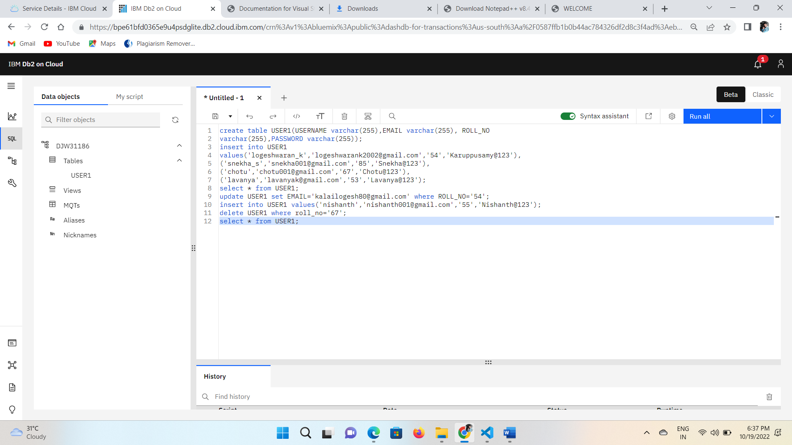

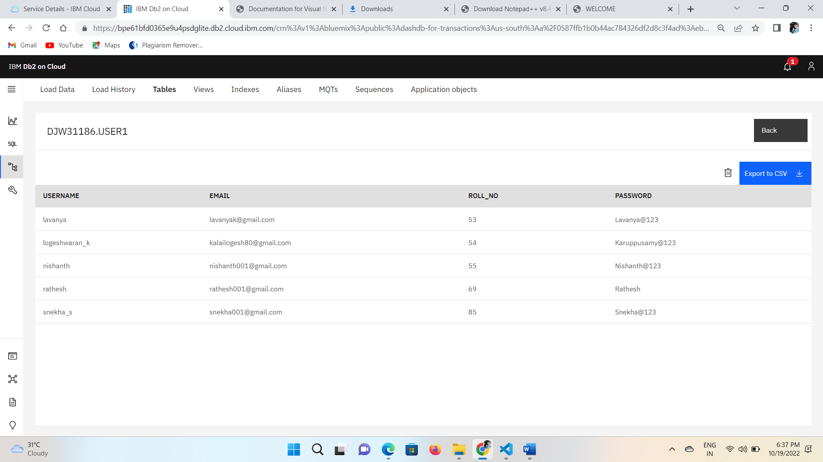

**3. Connect python to db2**

from flask import Flask, render_template, request, redirect, url_for, session

import ibm_db

import db2

import re

hostname = '9938aec0-8105-433e-8bf9-0fbb7e483086.c1ogj3sd0tgtu0lqde00.databases.appdomain.cloud'

uid = 'cjn94379'

pwd = 'Ep20Vfe3GyURJPRU'

driver = "{IBM DB2 ODBC DRIVER}"

db_name = 'Bludb'

port = '32459'

protocol = 'TCPIP'

dsn = (

"DATABASE ={0};"

"HOSTNAME ={1};"

"PORT ={2};"

"UID ={3};"

"SECURITY=SSL;"

"PROTOCOL={4};"

"PWD ={5};"

).format(db_name, hostname, port, uid, protocol, pwd)

print(dsn)

try:

    print("Connecting to db2.....")

    db2 = ibm_db.connect(dsn, "", "")

    print()

    print("Connected to database")

    print("Connection Successful!!!")

except Exception as exception:

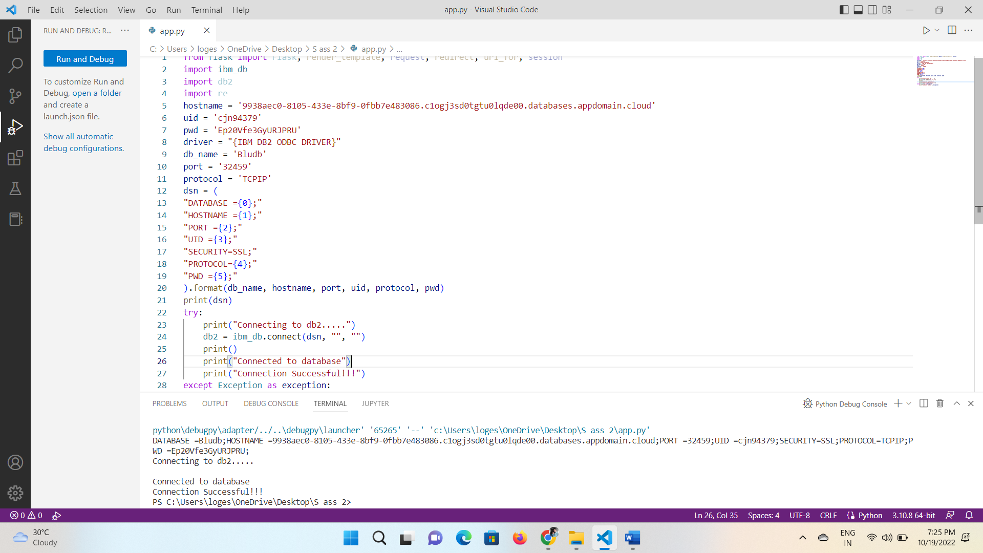

**4) ACCESS LOGIN WITH CONNTING TO DATABASE**

from flask import Flask, render_template, request, redirect, url_for, session

import ibm_db

import re

app = Flask(__name__)

hostname = '9938aec0-8105-433e-8bf9-0fbb7e483086.c1ogj3sd0tgtu0lqde00.databases.appdomain.cloud'

uid = 'cjn94379'

pwd = 'Ep20Vfe3GyURJPRU'

driver = "{IBM DB2 ODBC DRIVER}"

db_name = 'Bludb'

port = '32459'

protocol = 'TCPIP'

dsn = (

"DATABASE ={0};"

"HOSTNAME ={1};"

"PORT ={2};"

"UID ={3};"

"SECURITY=SSL;"

"PROTOCOL={4};"

"PWD ={5};"

).format(db_name, hostname, port, uid, protocol, pwd)

connection = ibm_db.connect(dsn, "", "")

print()

# query = "SELECT username FROM USER1 WHERE username=?"

# stmt = ibm_db.prepare(connection, query)

# ibm_db.bind_param(stmt, 1, username)

# ibm_db.execute(stmt)

# username = ibm_db.fetch_assoc(stmt)

# print(username)

app.secret_key = 'a'

@app.route('/', methods=['GET', 'POST'])

@app.route('/register', methods=['GET', 'POST'])

def register():

    msg = " "

    if request.method == 'POST':

        username = request.form['username']

        email_id = request.form['email_id']

        phone_no = request.form['phone_no']

        password = request.form['password']

        query = "SELECT * FROM USER1 WHERE username=?;"

        stmt = ibm_db.prepare(connection, query)

        ibm_db.bind_param(stmt, 1, username)

        ibm_db.execute(stmt)

        account = ibm_db.fetch_assoc(stmt)

        if (account):

            msg = "Account already exists!"

            return render_template('register.html', msg=msg)

        # elif not re.match(r'[^@]+@[^@]+\.[^@]+', email_id):

        #     msg = "Invalid email addres"

        # elif not re.match(r'[A-Za-z0-9+', username):

        #     msg = "Name must contain only characters and numbers"

        else:

            query = "INSERT INTO USER1 values(?,?,?,?)"

            stmt = ibm_db.prepare(connection, query)

            ibm_db.bind_param(stmt, 1, username)

            ibm_db.bind_param(stmt, 2, email_id)

            ibm_db.bind_param(stmt, 3, phone_no)

            ibm_db.bind_param(stmt, 4, password)

            ibm_db.execute(stmt)

            msg = 'You have successfully Logged In!!'

            return render_template('login.html', msg=msg)

    else:

        msg = 'PLEASE FILL OUT OF THE FORM'

        return render_template('register.html', msg=msg)

@app.route('/login', methods=['GET', 'POST'])

def login():

    global userid

    msg = ' '

    if request.method == "POST":

        username = request.form['username']

        password = request.form['password']

        query = "select * from user1 where username=? and password=?"

        stmt = ibm_db.prepare(connection, query)

        ibm_db.bind_param(stmt, 1, username)

        ibm_db.bind_param(stmt, 2, password)

        ibm_db.execute(stmt)

        account = ibm_db.fetch_assoc(stmt)

        print(account)

        if account:

            session['Loggedin'] = True

            session['id'] = account['USERNAME']

            session['username'] = account['USERNAME']

            msg = 'Logged in Successfully'

            return render_template('welcome.html', msg=msg, username=str.upper(username))

        else:

            msg = 'Incorrect Username or Password'

            return render_template('login.html', msg=msg)

    else:

        msg = 'PLEASE FILL OUT OF THE FORM'

        return render_template('login.html', msg=msg)

@app.route('/welcome', methods=['GET', 'POST'])

def welcome():

    if request.method == 'POST':

        username = request.form['username']

        print(username)

        return render_template('welcome.html', username=username)

    else:

        return render_template('welcome.html', username=username)

if __name__ == "__main__":

    app.run(debug=True)

    app.run(host='0.0.0.0')